**Normality Assumption**

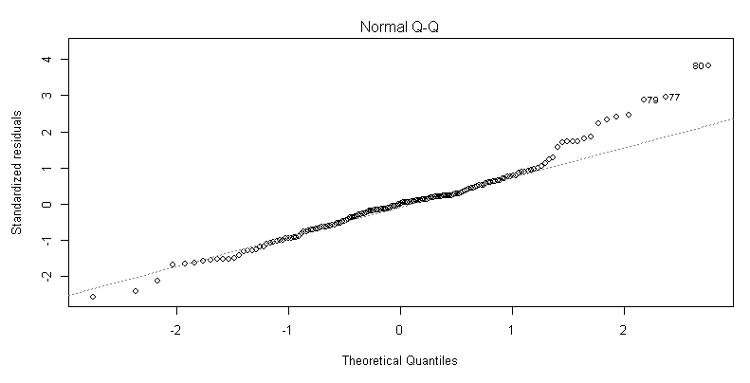

The left side of the QQ Plot looks pretty good, but the right side looks awful. I believe the normality assumption to be violated.

**Linearity Assumption**

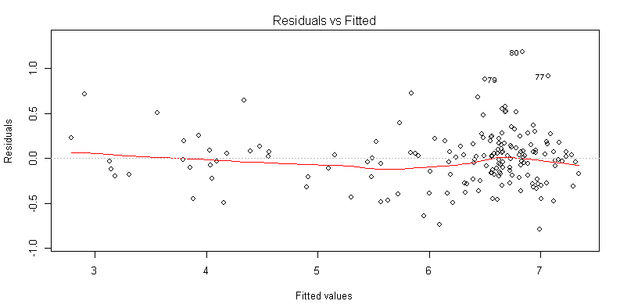

The linearity assumption seems to be met. There is no obvious pattern here

**Homoscedasticity Assumption**

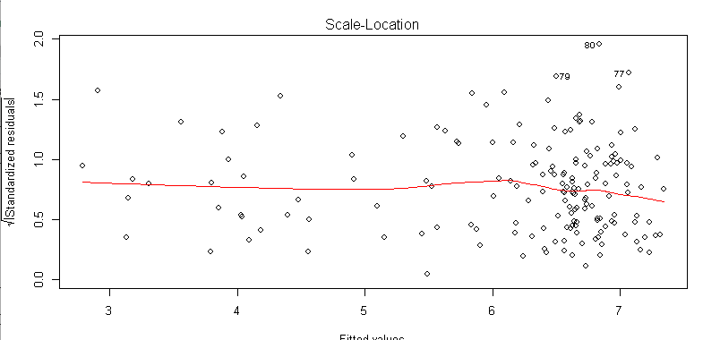

Homoscedasticity assumption is met. No obvious fan shape.

**Influential Observations**

There are several points that showed up in my investigation as influential. Removing individual points did not have a significant effect on the models effectiveness.

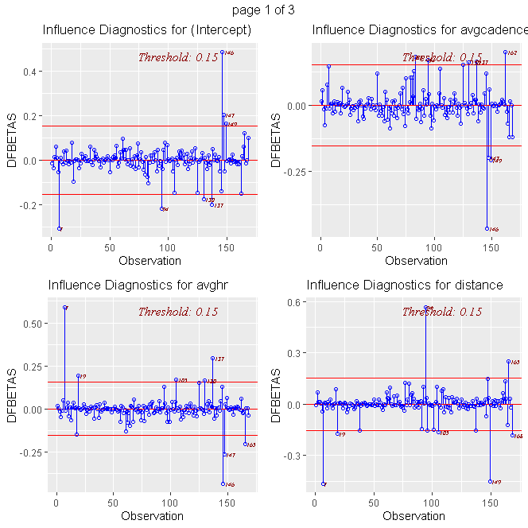

**Influential Observations (Continued)** 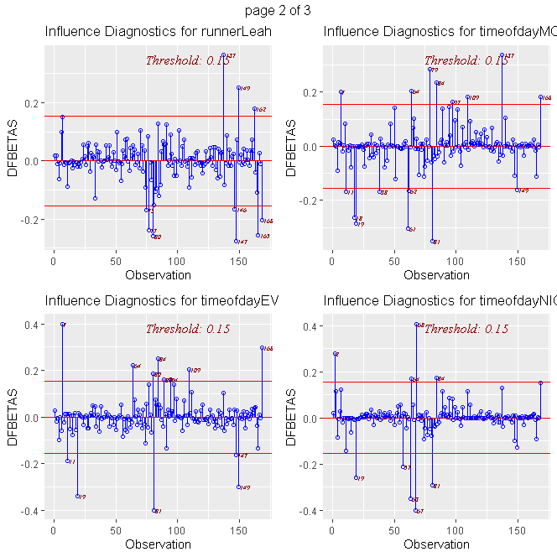

**Influential Observations (Continued)**

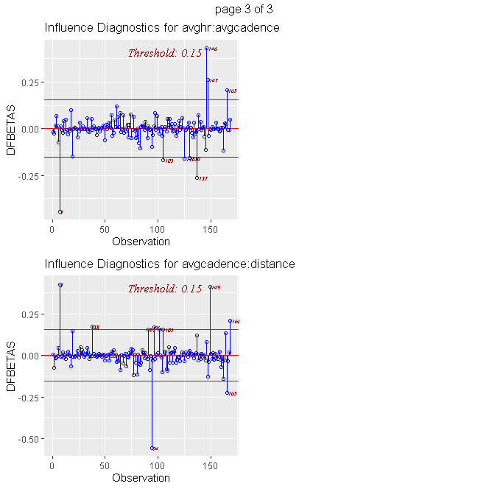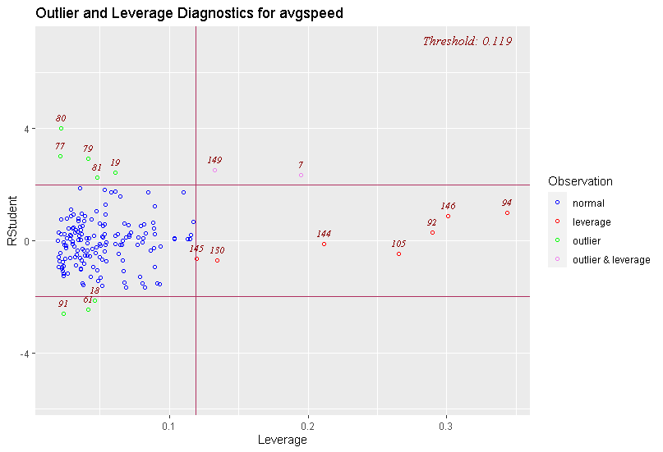

**Interpretation of Coefficients**

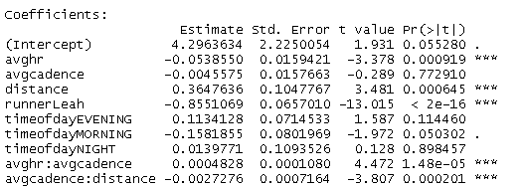

The Intercept coefficient of 4.296 can be interpreted as the average speed (in mph) for a run where all predictors are 0. This doesn’t make much sense in context as it wouldn’t really be a run if distance were 0. The other coefficients can be interpreted such that:

* Increasing average heart rate by 1 bpm has the effect of reducing the average speed by .054 mph when adjusting for average cadence.
* Increasing average cadence by 1 step per minute has the effect of reducing the average speed by .005 mph when adjusting for average heart rate and distance.
* Increasing distance by 1 mile has the effect of increasing the average speed by .365 mph when adjusting for average cadence.
* When Leah runs instead of Adam, we can expect a decrease in the average speed of .855 mph.
* Running in the evening increases the average speed by .113 mph.
* Running in the morning decreases the average speed by .158 mph.
* Running at night increases the average speed by .013 mph.
* Average Speed increases by 0.0004828 mph due to the interaction between avghr and avgcadence.
  + Ex: If the average heart rate was 160 beats per minute, we expect to observe an increase in avgspeed of 0.077248 mph for each additional step per minute.
* Average Speed decreases by 0.0027276 mph due to the interaction between avgcadence and distance.
  + Ex: If the average cadence was 170 steps per minutes, we expect to observe a decrease in avgspeed of 0.463692 mph for each additional mile run.

**Collapsing Categories**

I decided to investigate the effects of collapsing the levels of “timeofday”

I ran several linear hypothesis tests using the car package. The following two had significant p-values.

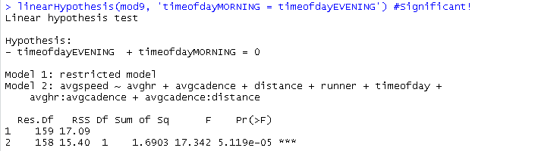

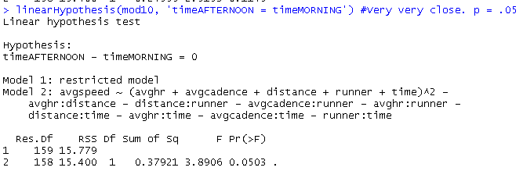

I used the rockchalk package to combine the levels of “timeofday” into two options:

Option 1: Night and No Night (Combining Morning, Afternoon, Evening into one level)

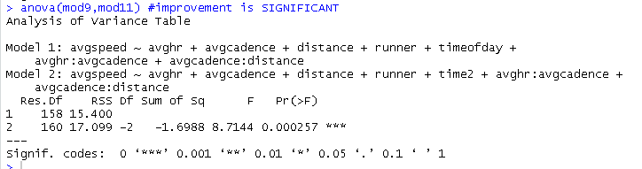

Option 2: Night, Afternoon, Mo-Ev (Combining Morning and Evening into one level)

I already knew this would be an improvement from my original model from the linear hypothesis test, but I wanted to compare the results to Option 1:

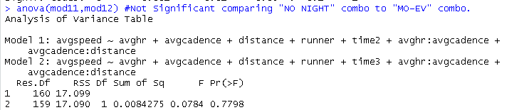

Because there wasn’t a significant difference between the two options, I decided the Night vs No Night option made more logical sense.